**Report**

**INT301: Open Source Technologies**

**Continuous Assessment**

**By**

**Shubham Singh**

**11902541**

**Roll no: 05**



**School Of Computer Science and Engineering**

**Lovely Professional University,**

**Punjab, 144401**

**STUDENT DECLARATION:**

This is to bring to notice that this report has been written by Shubham Singh No part of thereport is copied from other sources. All information included from other sources havebeenduly acknowledged. we aver that if any part of the report is found to be copied, we shall takefull responsibility for it. We would like to express our special thanks to our mentor Mr.Manpreet Singh for his timeand efforts he provided throughout the year. Your useful advice and suggestions were helpful to us during the project’s completion. In this aspect, we are eternally grateful to you.

Shubham Singh : 11902541

Objecttive of the Project

The objective of this project is to use HWiNFO, an open-source software tool, to obtain detailed information about various system components such as the CPU, motherboard, monitor, audio, network, and other peripherals. Additionally, the project aims to display the current and average speed/rate of the memory, hard drive, and CPU.

By displaying this information, the project aims to help users optimize their system performance by identifying hardware bottlenecks and troubleshooting issues. The project also aims to promote the use of open-source software by providing an alternative to proprietary or closed-source solutions.

**Overall, the objectives of this project are:**

1. To use HWiNFO to obtain detailed system information about various hardware components, including the CPU, motherboard, monitor, audio, network, and other peripherals.

2. To display the current and average speed/rate of the memory, hard drive, and CPU.

3. To help users optimize their system performance by identifying hardware bottlenecks and troubleshooting issues.

4. To promote the use of open-source software by providing an alternative to proprietary or closed-source solutions.

Description

This project aims to use HWiNFO, an open-source system information tool, to display detailed information about various hardware components such as the CPU, motherboard, monitor, audio, network, and other peripherals. The software is capable of providing hardware specifications and performance metrics, including the current and average speed/rate of the memory, hard drive, and CPU.

The project involves installing HWiNFO on an Ubuntu operating system and using its command-line interface (CLI) to obtain detailed information and performance metrics about the system components. The software's accuracy and reliability will be evaluated, and its user interface will be tested for ease of use and comprehensibility.

Once the software is installed and tested, the project will involve using HWiNFO to gather detailed system information and performance metrics for troubleshooting issues, identifying hardware bottlenecks, and optimizing system performance. The software's comprehensive reporting capabilities will enable users to obtain detailed information about their system components and identify potential performance issues.

The project also aims to promote the use of open-source software and provide users with an alternative to proprietary or closed-source solutions. By using an open-source system information tool like HWiNFO, users can obtain detailed hardware specifications and performance metrics without relying on proprietary solutions, which provides greater transparency, flexibility, and control over their system.

Overall, the goal of this project is to demonstrate how open-source software like HWiNFO can be used to obtain comprehensive and accurate system information and performance metrics, allowing users to optimize and maintain their system performance.

**System Description:**

**Operating System:** Any linux based OS

**CPU:** 64-bit processor with 2 cores

**RAM:** 4 GB for better performance

**Storage**: 20 GB disk space

**Networking:** Ethernet adapter with internet connectivity

Scope

The scope of this project is to use HWiNFO, an open-source software, to display detailed system information about various hardware components, including the CPU, motherboard, monitor, audio, network, and other peripherals. HWiNFO can also provide hardware specifications and performance metrics such as the current and average speed/rate of the memory, hard drive, and CPU.

The project involves installing HWiNFO on an Ubuntu operating system and using its command-line interface (CLI) to obtain system information and performance metrics. The software should be tested to ensure its accuracy and reliability, and its user interface should be evaluated for ease of use and comprehensibility.

Once the software is installed and tested, the project will involve using HWiNFO to gather detailed system information and performance metrics for troubleshooting issues, identifying hardware bottlenecks, and optimizing system performance. The software's comprehensive reporting capabilities will enable users to obtain detailed information about their system components and identify potential performance issues.The scope of the project also involves promoting the use of open-source software and providing users with an alternative to proprietary or closed-source solutions. The project aims to demonstrate the benefits of using open-source software, including greater flexibility, transparency, and control over system performance.

Overall, the scope of the project is to use HWiNFO, an open-source software, to obtain comprehensive and accurate system information and performance metrics for various hardware components, allowing users to optimize and maintain their system performance.

## **GitHub Link:**[**Click Here to Open Project code on github**](https://github.com/Shubham091234/ca3)

# Screenshots of Project:

## 1.To display the overview, the log information of hardware can be retrieved using the “hwinfo” command:

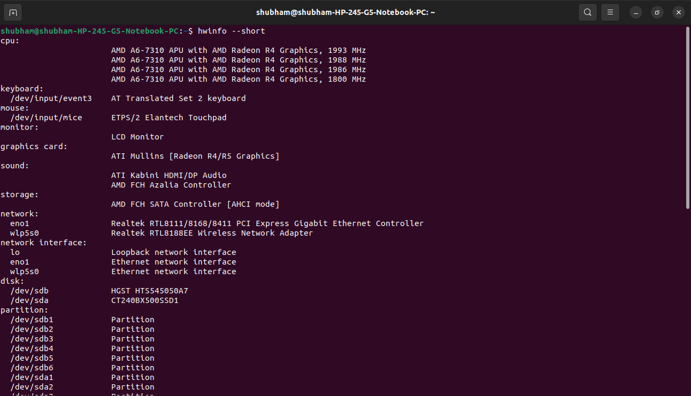

## Display System architecture details

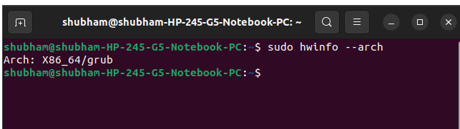

## Display Memory details

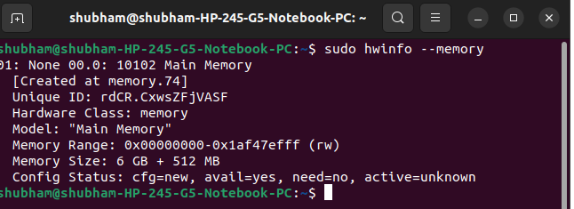

## To Retrieve the CPU Information

The “hwinfo” can be used to retrieve the information of the specific hardware component as well. For instance, you can retrieve the information of the CPU via the following command:

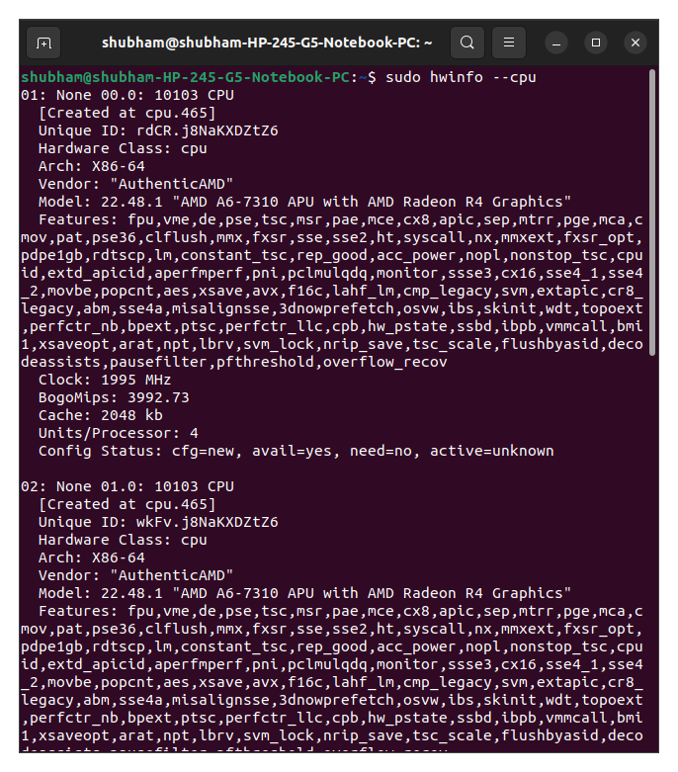

## To Get the Monitor Information

Similarly, to get the information about the Monitor, you can use the below-mentioned command in the terminal:

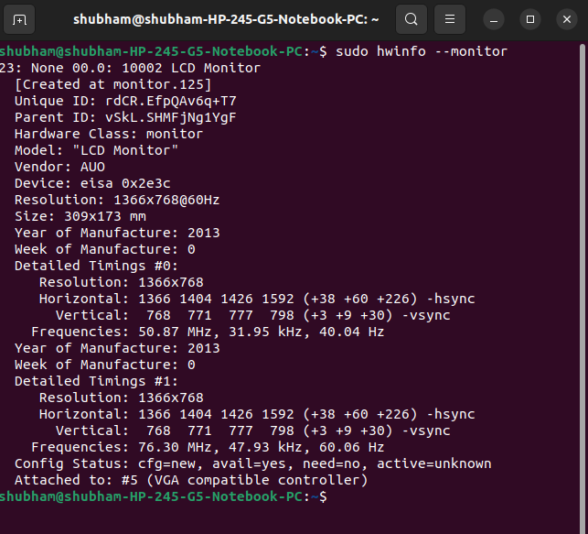

## 

## 

## To Retrieve the Network Information

Using the “hwinfo” command, the network information can be obtained as follows:

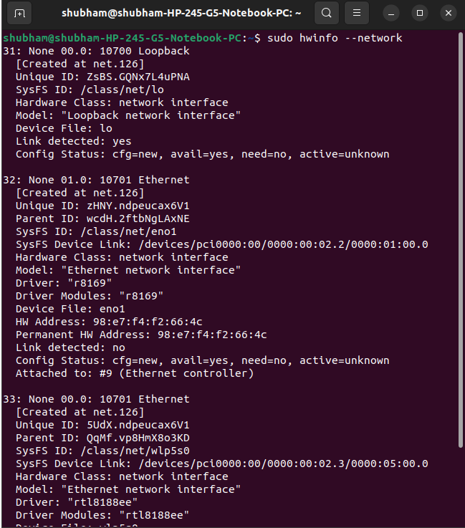

## To Get the Partition Information

The “hwinfo” command can be used to display the disk partition information. Execute the given command:

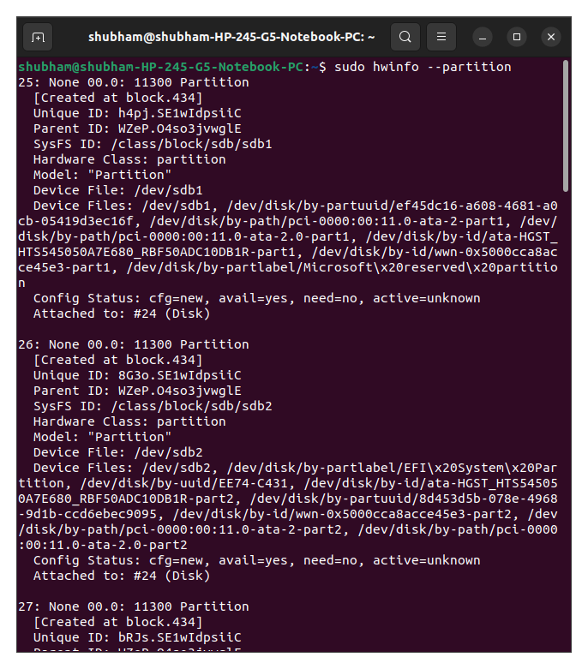

## To Get the Sound Card Information

Using the “hwinfo” command, the sound card information is obtained as follows:

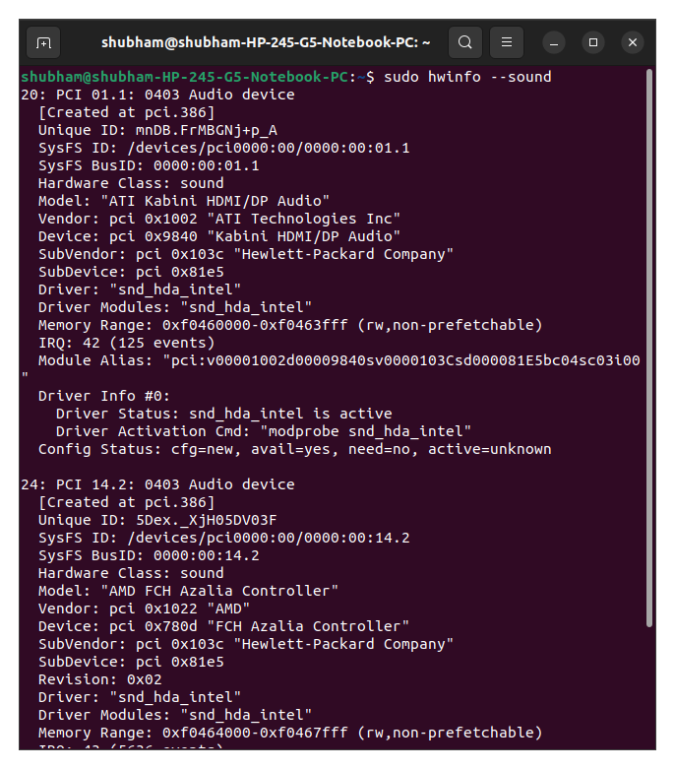

## To get the information about storage

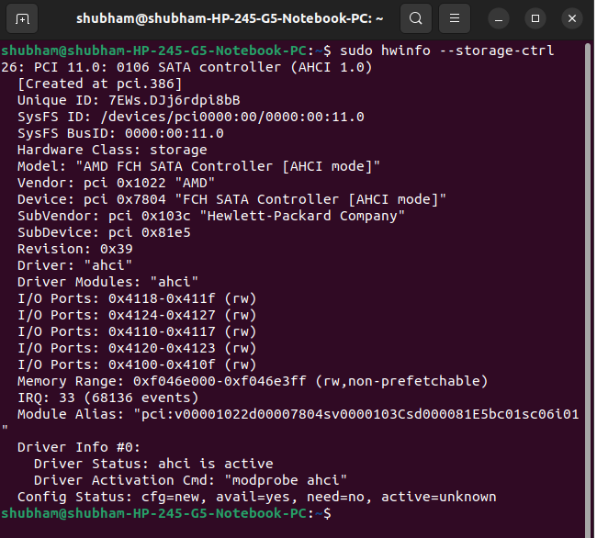

## To Get the BIOS Information

Using the “hwinfo” command, BIOS information is obtained as follows:

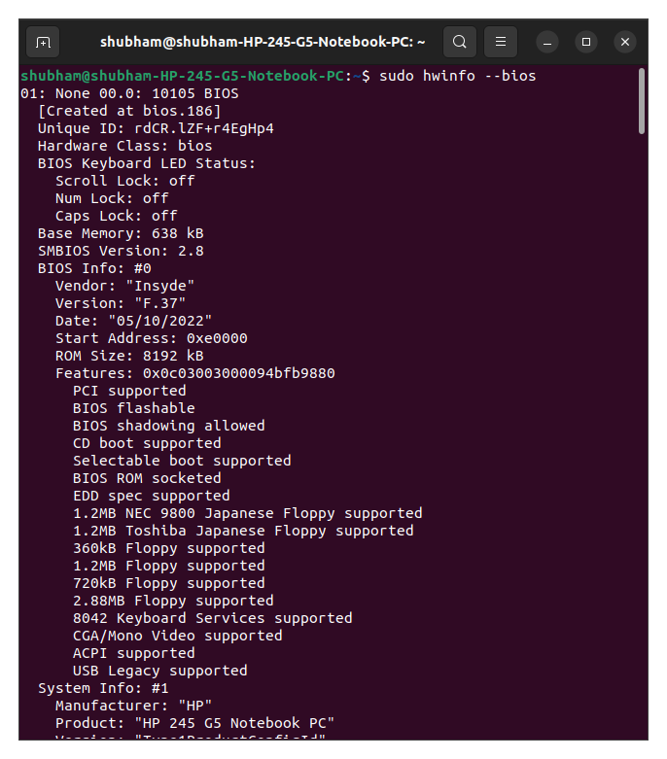

## To get the Speed of the CPU:

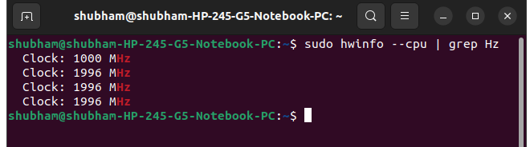

## To get information about Mouse:

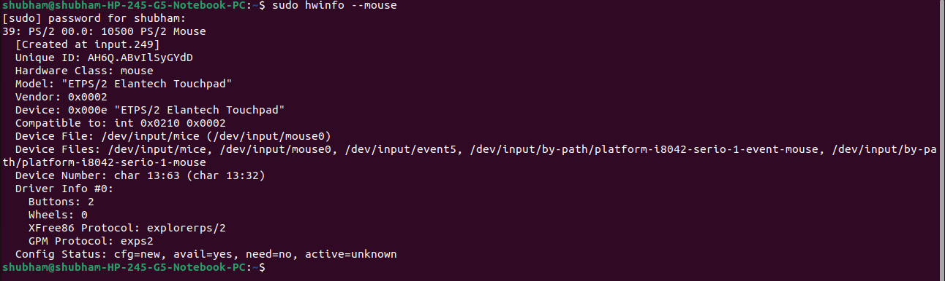

## To Get the Disks Information

Similarly, to get the information about the disks, you can use the below-mentioned command in the terminal:

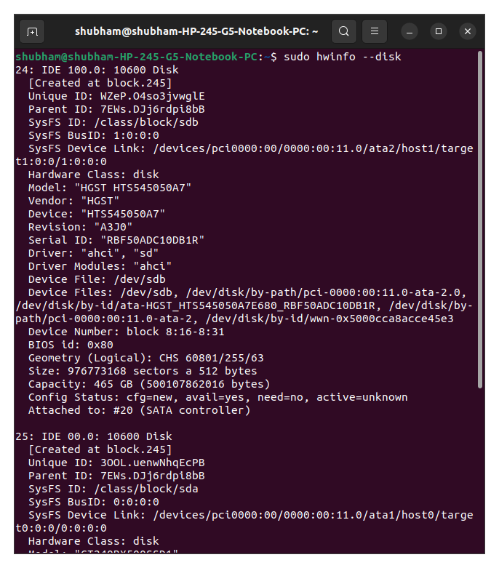

## Screenshot of Script:

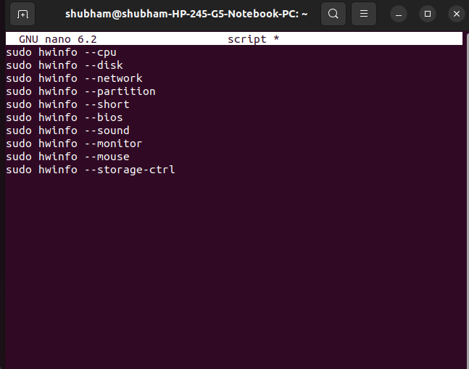

## 

## Screenshot of Output of Script:

